**Done by: Lohan Angammana (u3178318) Unit name:** **Programming for Design (11055)**

Flow chart

*Flow chart describing how program will work (how the self-portrait will appear on screen)*

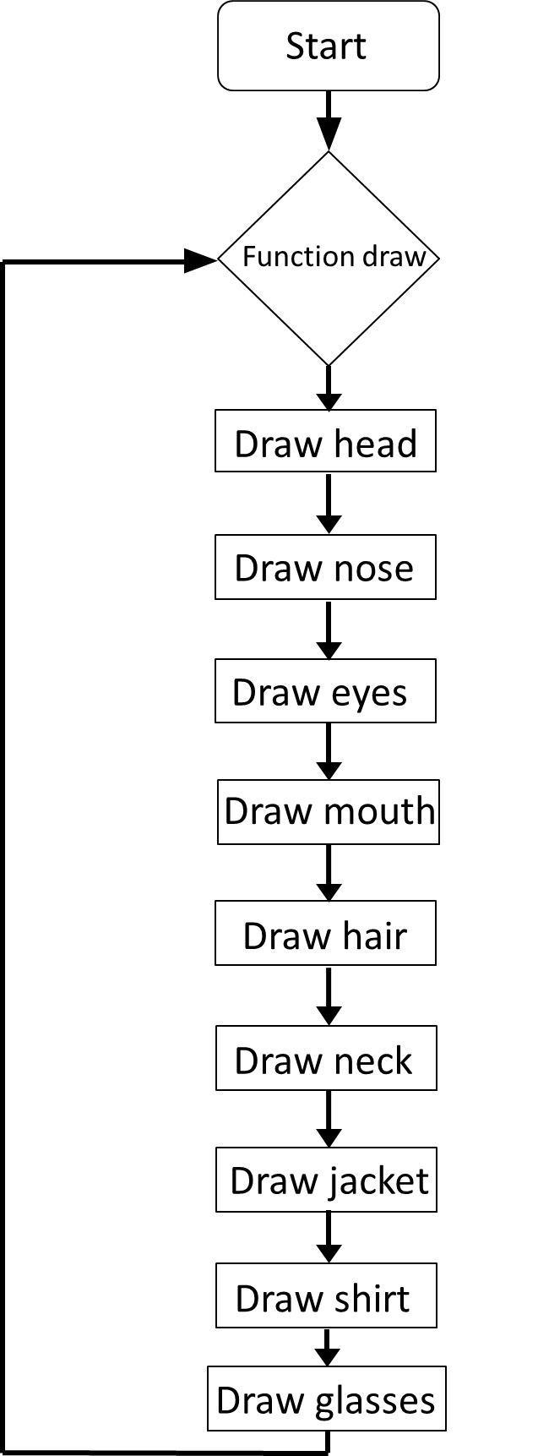

*Flow chart describing how self-portrait is interactive (how colours of jacket and shirt change when mouse button is clicked on screen)*

